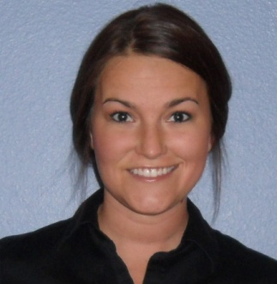**Chelsea G. Cox**

10645 SW Citation Dr.

Beaverton, OR 97008

Cell: (503) 348-4256

Email: chelseagcox@gmail.com

***OBJECTIVE:***

Recent college graduate eager to gain experience, learn business concepts, and capitalize on management and international business education.

***QUALIFICATIONS:***

Works well without supervision

Natural leader and motivator

Experience overseas and the ability to view problems from culturally different perspectives

Ability to prioritize and remain focused on the essence of an issue

Excellent with multi-tasking and organization

Skilled at learning new concepts quickly while working well under pressure

***EDUCATION:***

June 2010 **Bachelor in Business Admin.** Oregon State University Corvallis, OR

* Focus on Management and International Business
* Played intramural sports
* Active in Greek Life
* Completed exchange program to Singapore for 5 months
* Group leader in the study abroad introduction class

Dec 2009 **International Business Option** Singapore Management Univ. Singapore

* Explored popular global mega trends
* Studied corporate creativity from an Asian perspective
* Gained knowledge of portfolio management and stock market trends in the region

May 2004 **High School Diploma** Southridge High School Beaverton, OR

* Member of the National Honors Society
* Played Varsity softball, and Junior Varsity basketball and volleyball
* Active in Student leadership

***INTERNATIONAL EXPERIENCE:***

2009-10 Arthur Stonehill International Business Exchange Program in Singapore

Also visited: Indonesia, Malaysia, China, Thailand, Cambodia, Laos, Vietnam

2007&10 5 week combined trip to France, Spain, Italy, Holland, Belgium and Turkey

***PAID WORK AND VOLUNTEER EXPERIENCE:***

June ’10- Current Server Bugatti’s Italian Ristorante Beaverton, OR

2007- June ‘10 Server/Bartender McMenamins Corvallis, OR

2004-07 Server TGIFridays Portland, OR

2007-2008 Volunteer Boys & Girls Club Corvallis, OR

***SOFTWARE EXPERIENCE:***

Microsoft Works, Microsoft Office, Google Docs, Open Office, Microsoft Publisher, Microsoft Access, Adobe Photoshop, Adobe Illustrator, Microsoft PowerPoint, All Social Networking Sites, Picasa Photo Editor, Skype, iTunes, Kindle software, Mobile Apps